
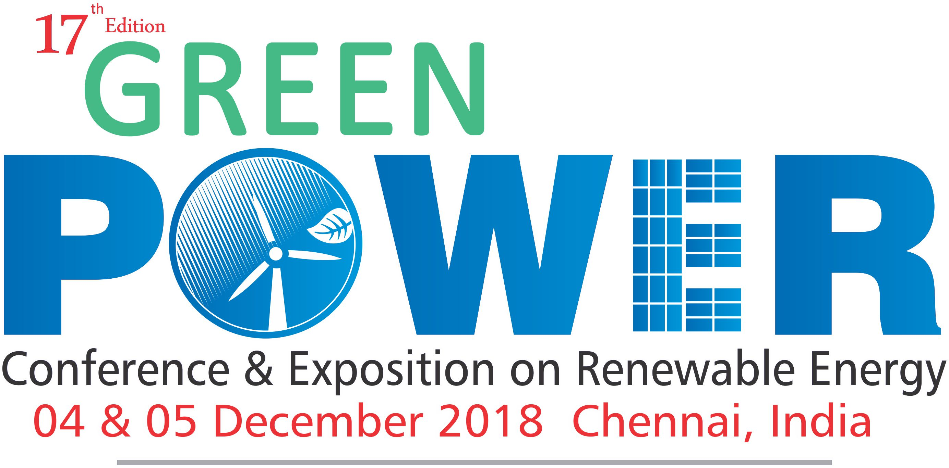

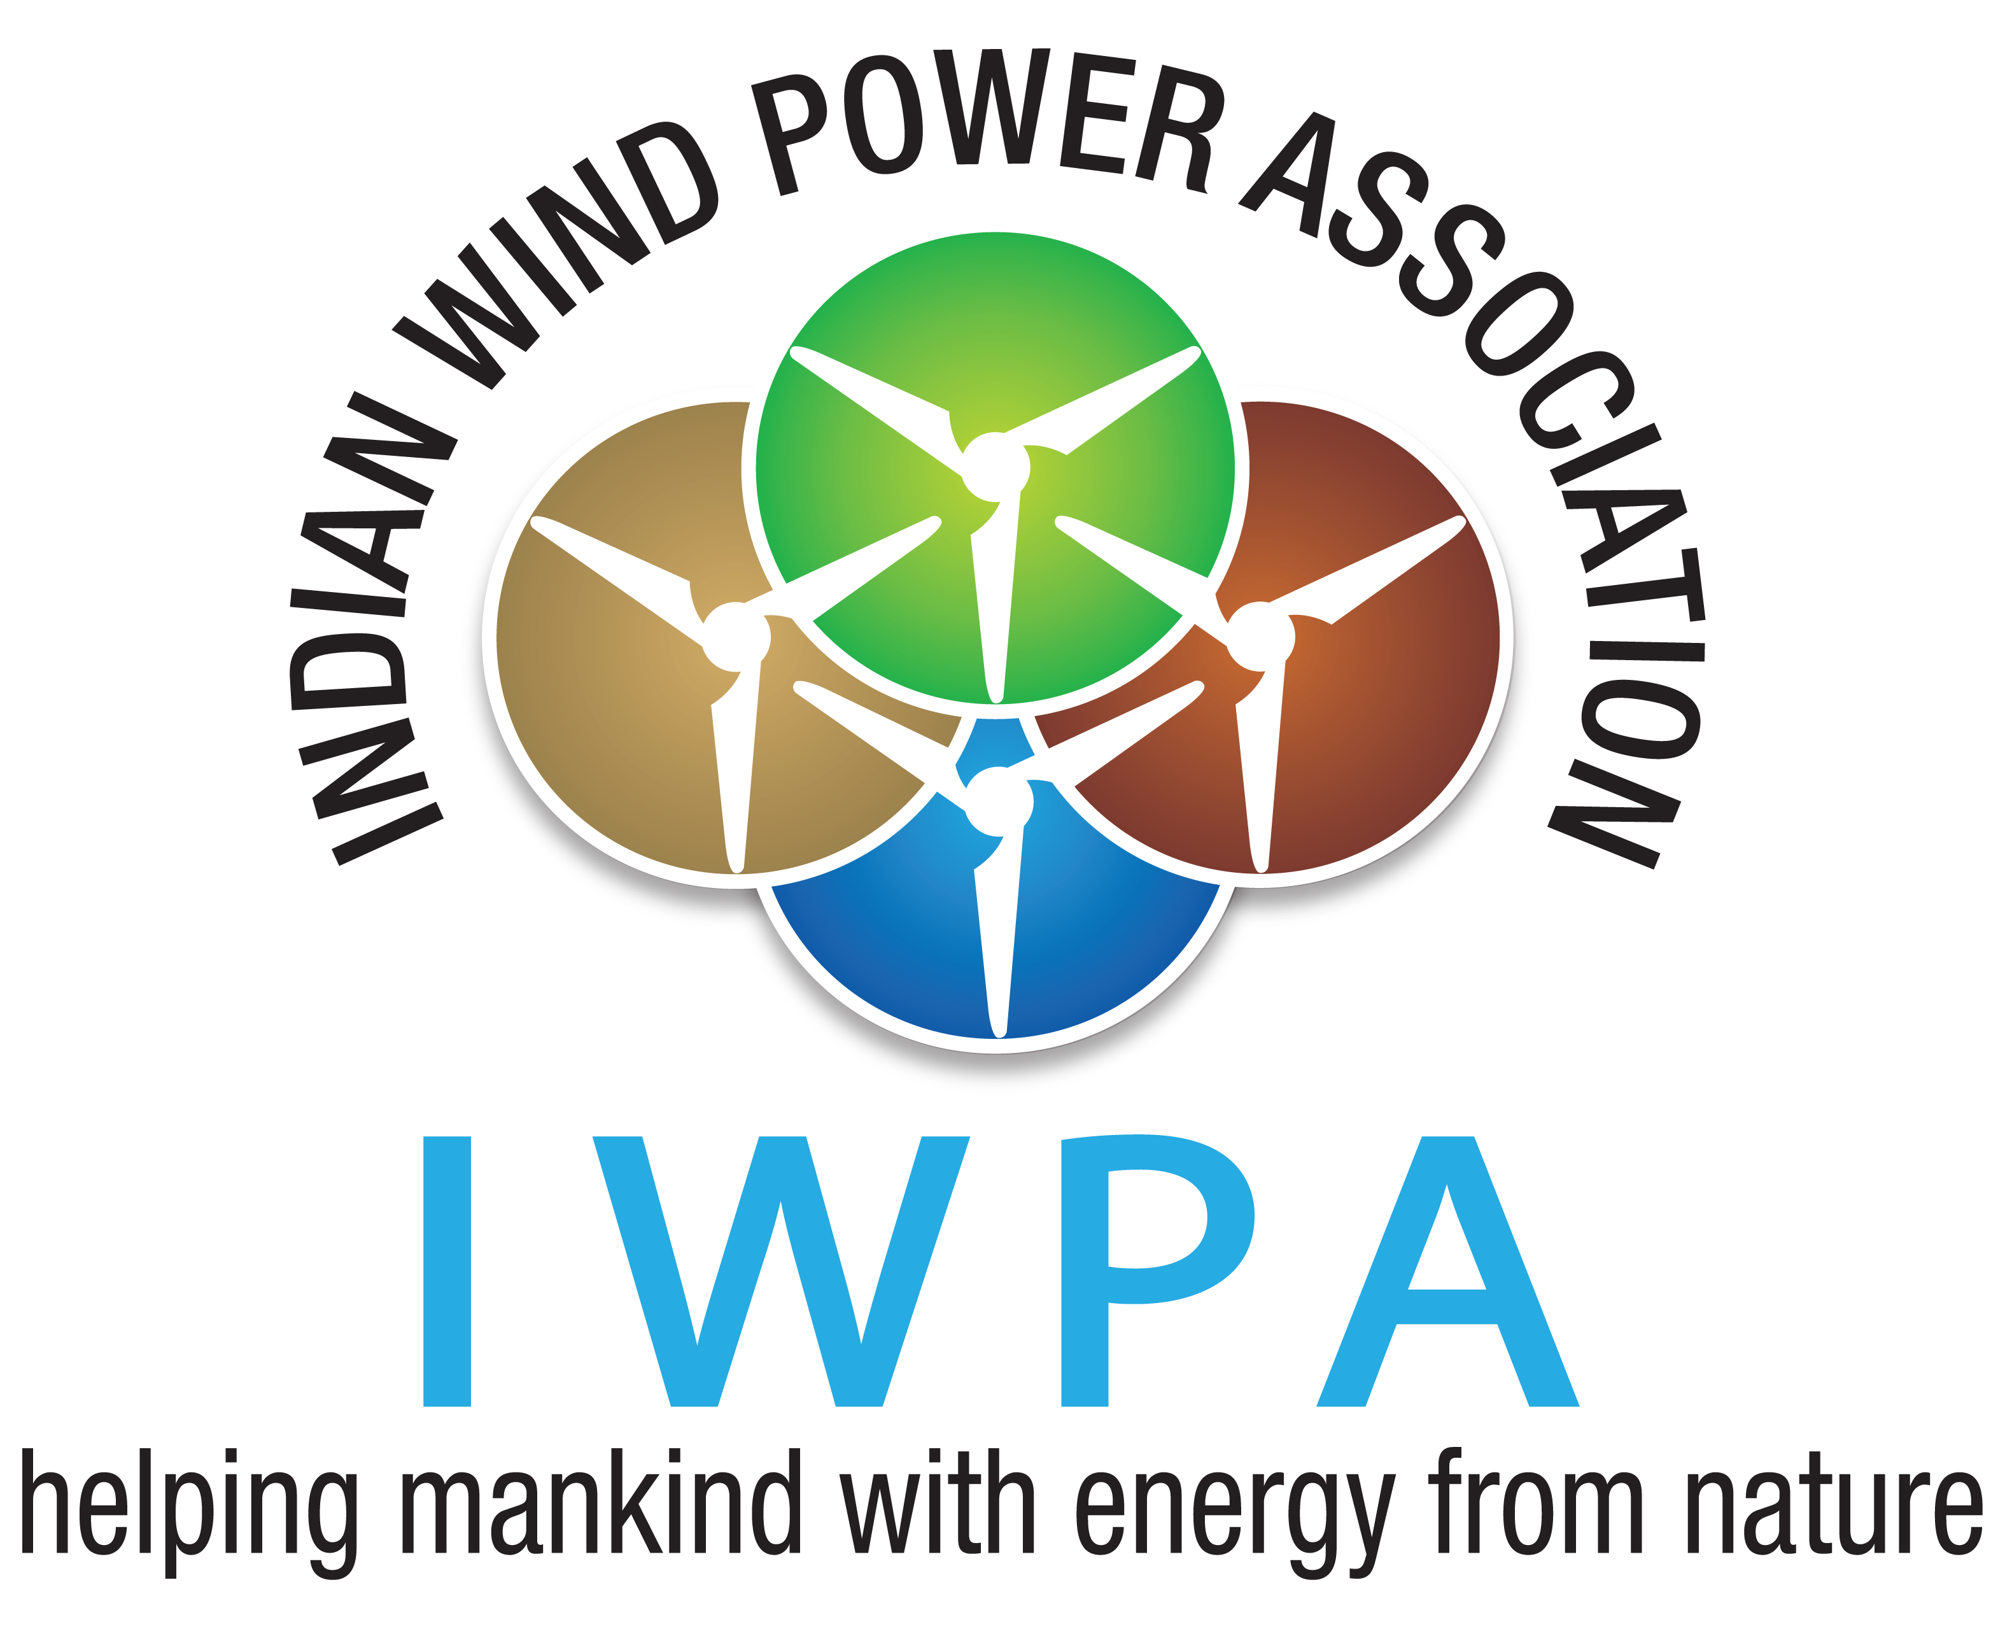

Green Power 2018
Conference and Exposition on Renewable Energy
04 & 05 December 2018: Hotel ITC Grand Chola, Chennai

Registration Form
We are pleased to nominate the following participant (s) for the programme:
Sl. No. | Name | Designation | E-mail | Mobile | Amount (Rs.)
1
2
 |  |  |  |  | Total Amount
Online/NEFT payments accepted, details as below
As reflect in the invoice: ** Filling the below blanks is mandatory
Organization : ……………………………..……..…………………………………..……..…………..…….…………..…….
Address 1 : …………………………………..…….. Address 2 : ……….……………………………………
City : ……………………………..………….. Pin: ………………… Tel: ……………………………………….
GST No : ..…………………………..…………..
NOTE: The same will reflect in the invoice as mentioned above and no change is accepted after the invoice is generated.
Category | Base Registration Fee
IWPA Members | Rs. 2,000/-
^{INSTRUCTIONS:}
- Prior registration is essential
- Prior payment of participation fee is mandatory to attend the Programme
- Delegate fee once paid is non-refundable or adjustable in any other event; however change in nomination(s) is acceptable
- Programme is non- residential
CONTACT DETAILS:

Kampli Durga Sindhura| Confederation of Indian Industry (CII) | CII-Sohrabji Godrej Green Business Centre
Survey No -64, Kothaguda Post | Near Hitec City| Hyderabad-500084
T: + 91- 40 - 44185159 / Mob : 9493719283, Email : kampli.sindhura@cii.in

Banking Details of CII – GBC, Hyderabad

1) Bank Name : ICICI Bank Ltd, Madhapur Branch

2) Name of the Account : Confederation of Indian Industry

3) Bank Address : ICICI BANK LTD Stone Ridge Centre, Kondapur |Hyderabad – 500033 |Telengana

4) Bank Account No : 004005011896

5) Bank Branch Code : 0040

6) MICR Code : 500229003

7) IFSC/NEFT Code : ICIC0000040

8) Swift Code : ICICINBBCTS

9) Swift Address : LOYDGB2LXXX

For Payment through DD/ Company Cheque :

DD/ Company Cheque in favour of - Confederation of Indian Industry, payable at - Hyderabad

